**Project documentation**

**Project Tittle : LAPTOP REQUEST CATALOG ITEM**

**Team ID :**  NM2025TMID15305

**Team Leader :** GOWDHAM V

**Team member :**

NITHISH S

SURYA M

KADALARASU E

JAIGANESH N

**Category:** serviceNow system Administartor

Skills **Required :**

Research , Content Writing

**Laptop Request Catalog Item**

**Problem statement :**

**Employees in the organization need a quick and efficient way to request laptops for work. The current process is manual and prone to delays, with no dynamic form behavior to guide users or ensure accurate data collection. To address this, a Service Catalog item needs to be created, allowing users to easily request a laptop, with dynamic fields, clear instructions, and additional functionality like resetting the form if needed. The solution should also ensure all changes are tracked for governance and deployment.**

**Project tasks**

**TASK INITIATION**

**Milestone 1 : Update sets**

**Activity : Create local update set**

1. Open service now
2. Click on All >> search for update set
3. Select local update sets under system update set
4. Click on new
5. Fill the following details to create a update set as “ loptop request “
6. Click on submit and make current
7. By clicking on the button it activates the update set

**Milestone 2 : Service catalog item**

**Activity 1: Create service catalog item**

1. Open service now
2. Click on All >> service catalog
3. Select maintain items under catalog definition

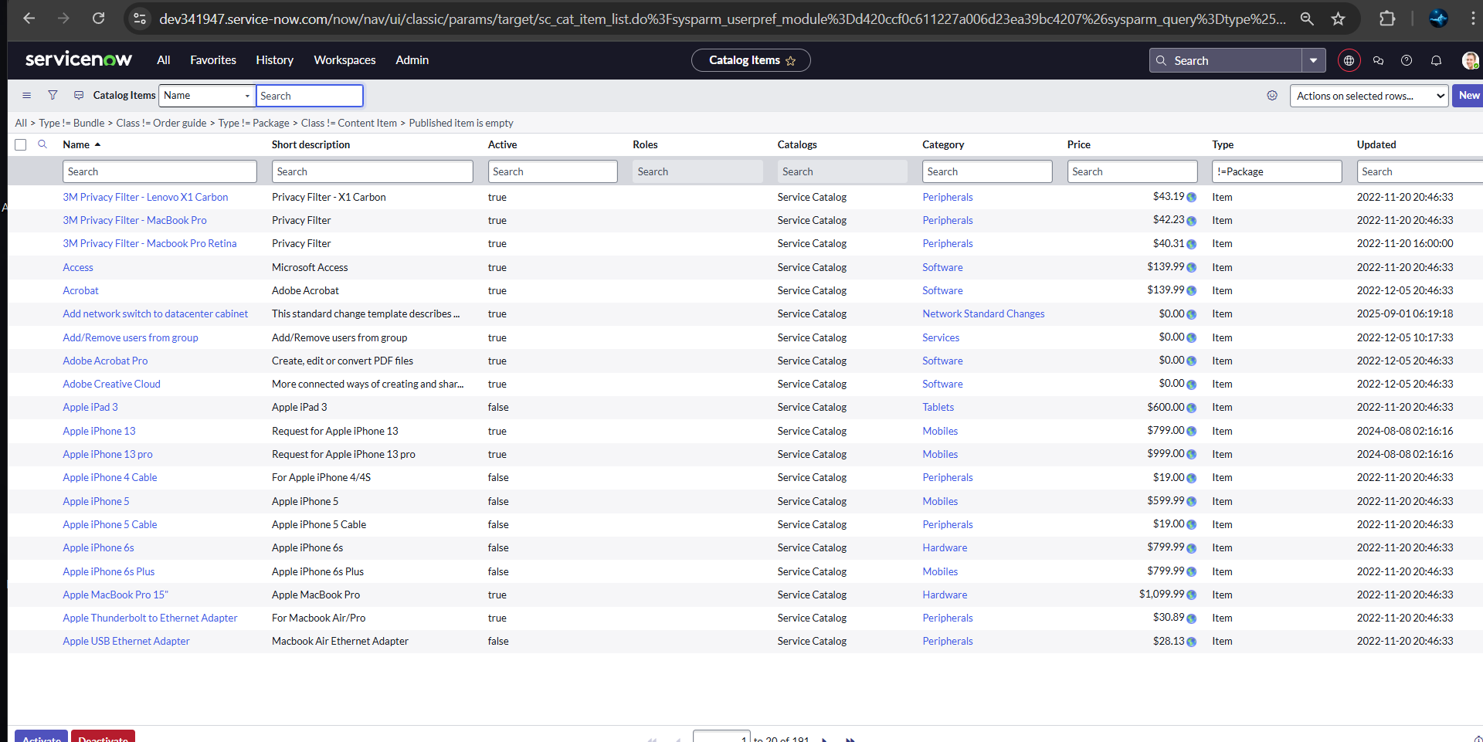

1. Fill the following details to create a new catalog a new item

Name : Laptop Request

Catalog service : service catalog

Category : Hardware

Short Description : use this item to request a new laptop

1. Click on ‘SAVE’

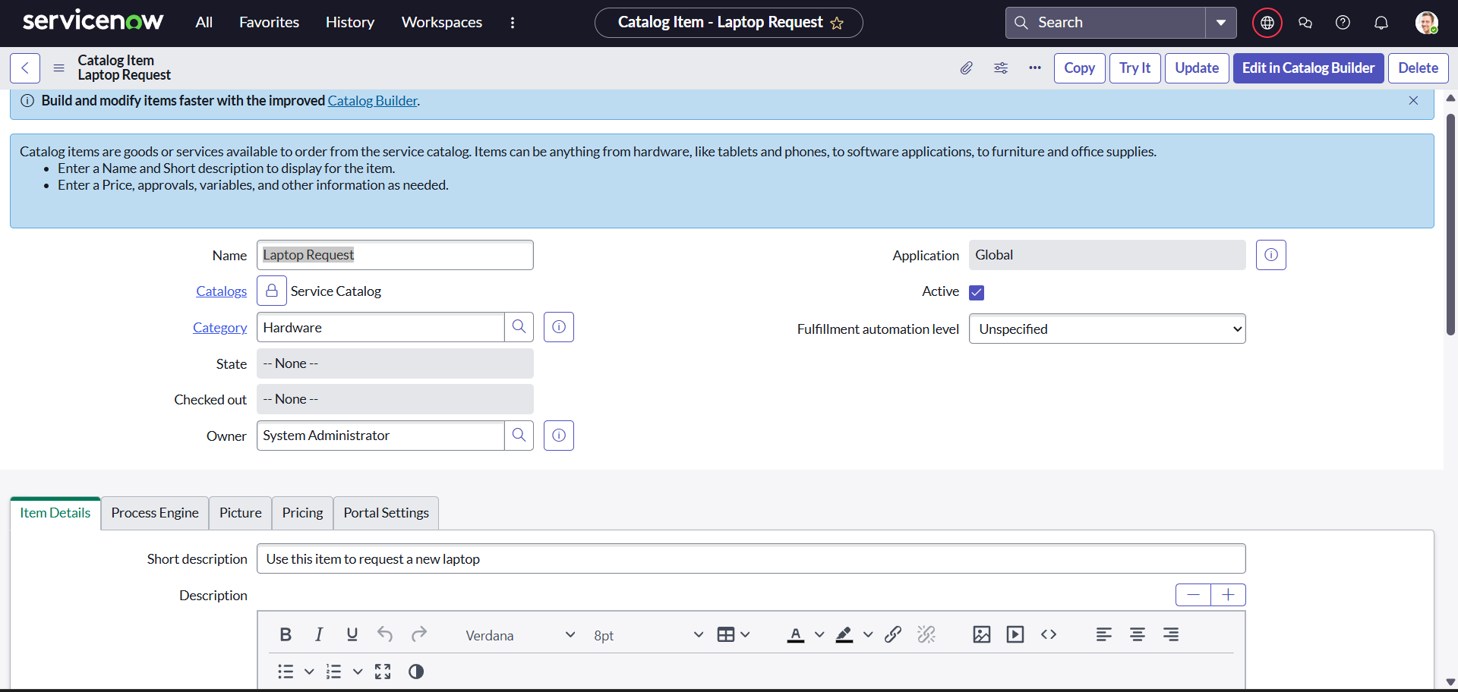

**Activity 2 : Add variables**

**Step 1 :**

* After saving the catalog item form scroll down and click on variable ( related list )
* Click on new enter and the details as below

1. Variable 1: Laptop model

Type : Single line text

Name : laptop_model

Order : 100

* Click on submit
* Again click on new and add remaining variable in the above process

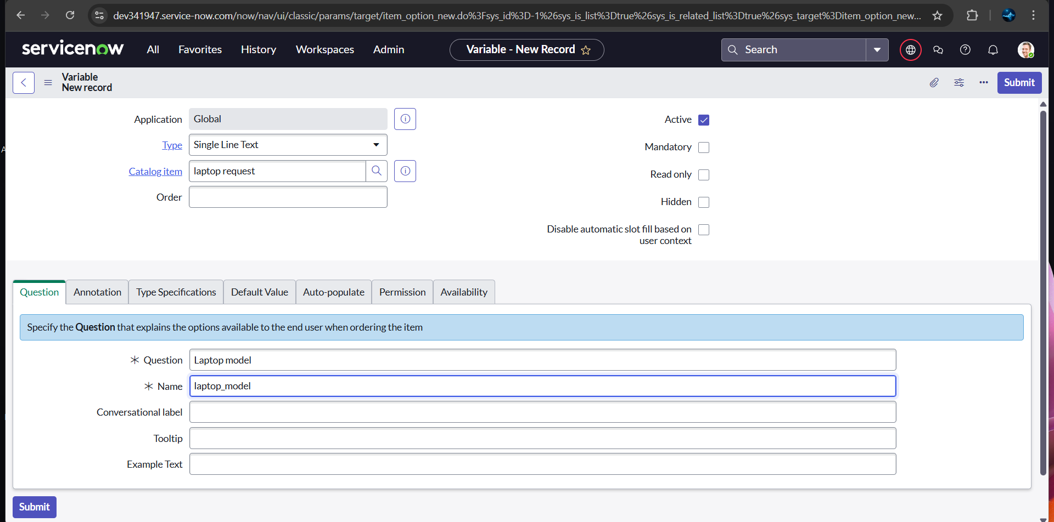

1. Variable 2: Justification

Type : Multi line text

Name : justification

Order : 200

1. Variable 3 : additional Accessories

Type : checkbox

Name: additional_accerssories

Order: 300

1. Variable 4 : Accessories details

Type : Multi line text

Name : accessories_details

Oeder : 400

**Step2:**

* After adding above variable which are added to newly created catalog item
* 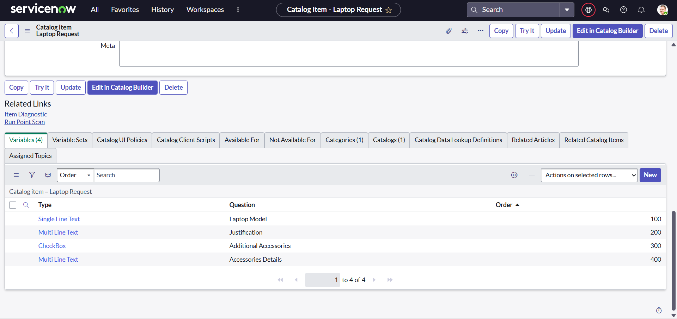Then save the catalog item form

**Milestone 3 : UI Policy**

**Activity : Create catalog ui policies**

1. Click on all>> search for service catalog
2. Select maintain item under catalog definition
3. Search for ‘laptop request’ which is created before
4. Select ‘laptop request’ and scroll down click on “Catalog Ui policies”
5. In the catalog ui policies related list tab click on new
6. Give short description as: show accessories details
7. Set the Catalog Condition in the related list tab ‘when to apply’

                  [field: additional_ accessories, operator: is, value:

Click on **save**.(do not click on submit)

1. Scroll down and select ‘catalog ui action’
2. Then click on new button
3. Select variable name as: accessories_details

                              Order:100

                    Mandatory: True

                         Visible : True

1. Click on save and again click save button of the catalog ui policy form

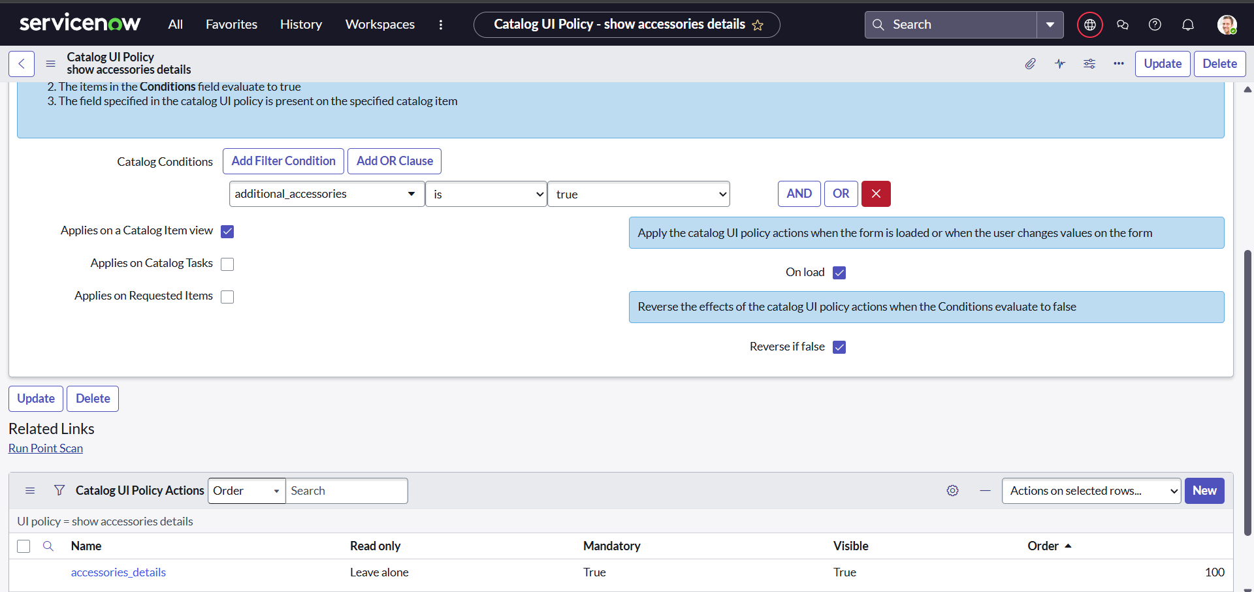

**Milestone 4: UI Action**

**Activity : Create ui action**

1. **Open service now.**
2. **Click on All  >> search for ui action**
3. **Select ui actions under system definition**
4. **Click on new**
5. **Fill the following details to create ui action**

**Table: shopping cart(sc_cart)  
              Order:100  
              Action name:  Reset form  
               Client : checked  
Script:  
    function resetForm() {  
    g_form.clearForm(); // Clears all fields in the form  
    alert("The form has been reset.");  
}**

1. **Click on save**A screenshot of a computer

   AI-generated content may be incorrect.

**Milestone 5 : Export update set**

**Activity : Exporting changes to another instance**

1. Click on All  >> search for update sets
2. Select local update set
3. Select created update set i.e. ‘Laptop Request Project’
4. Set the state to ‘Complete’
5. In the related list Update tab, updates are visible which we perform under this update set.
6. Click on export to XML ,it download one file

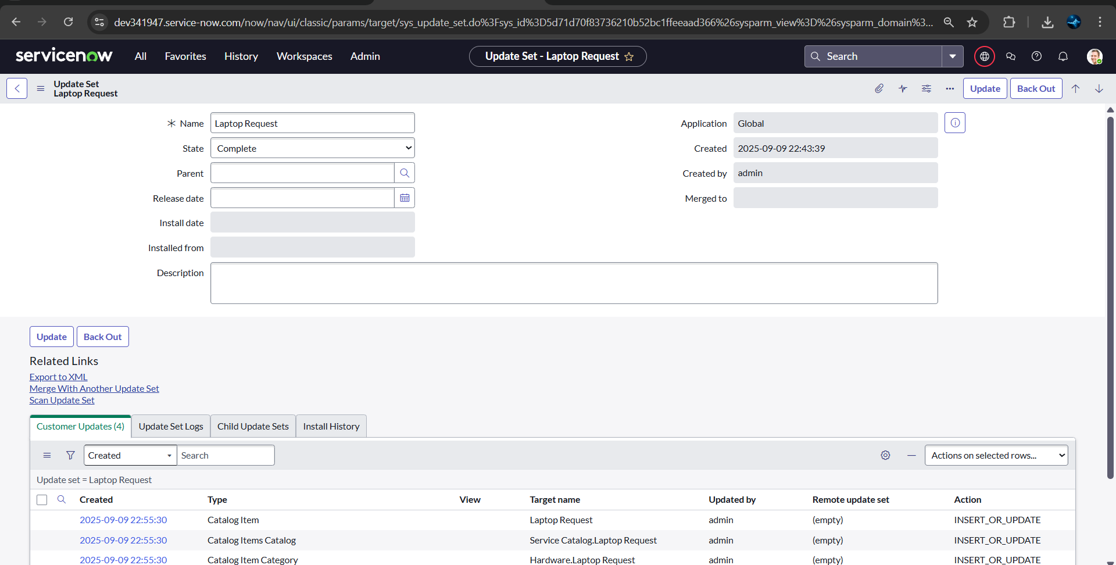

**Milestone 6 : Login to another instance**

**Activity : Retrieving the update set**

1. Open another instance in incognito window
2. Login with credentials
3. Click on all>> search for update sets
4. Select “Retrieved update set” under system update set
5. It open retrieved update set list and scroll down
6. 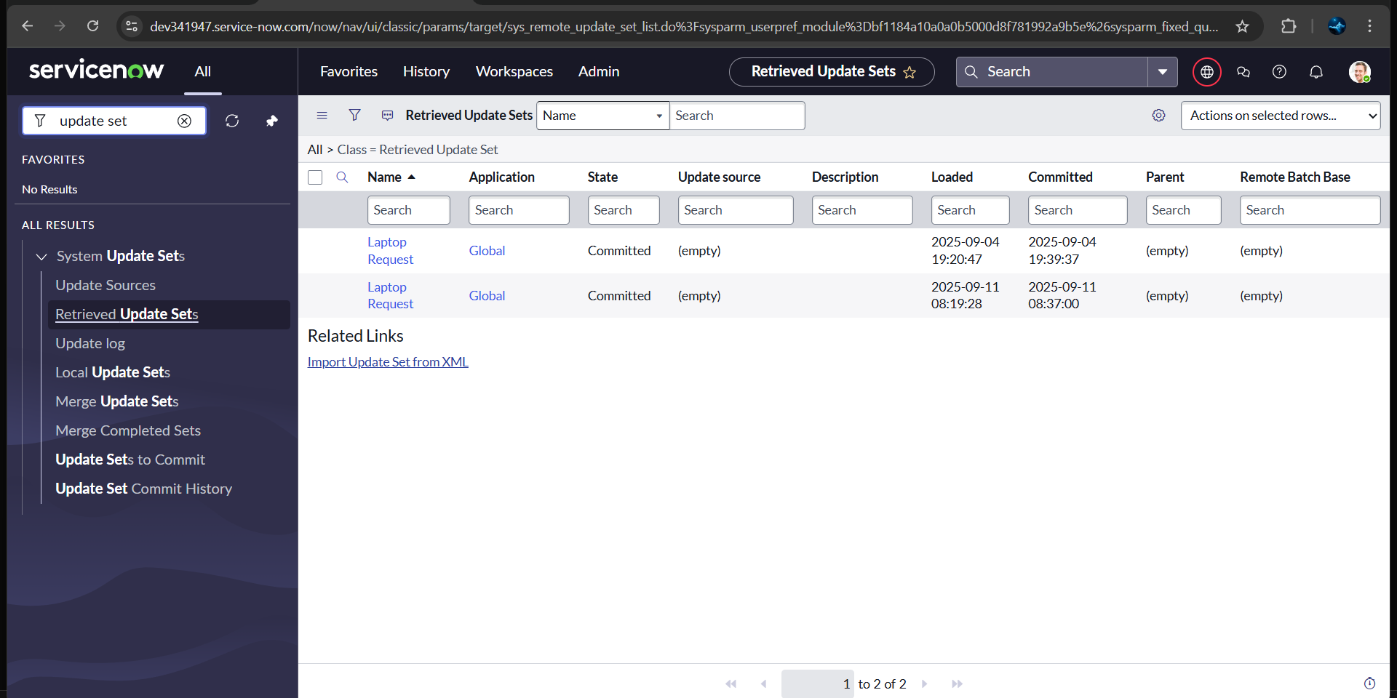Click on import update set from XML

7.Upload the downloaded file in XML file

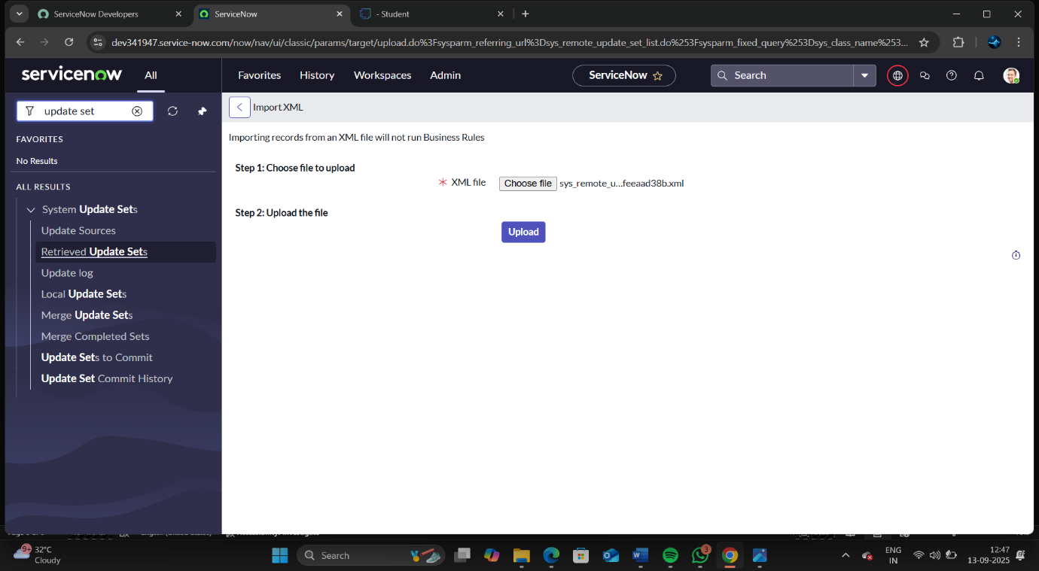8.Click on Upload and it gets uploaded

9.Open retrieved update set ‘laptop request project’

10.Click on preview update set

11.And click on commit update set

12.And also see the related tab updates

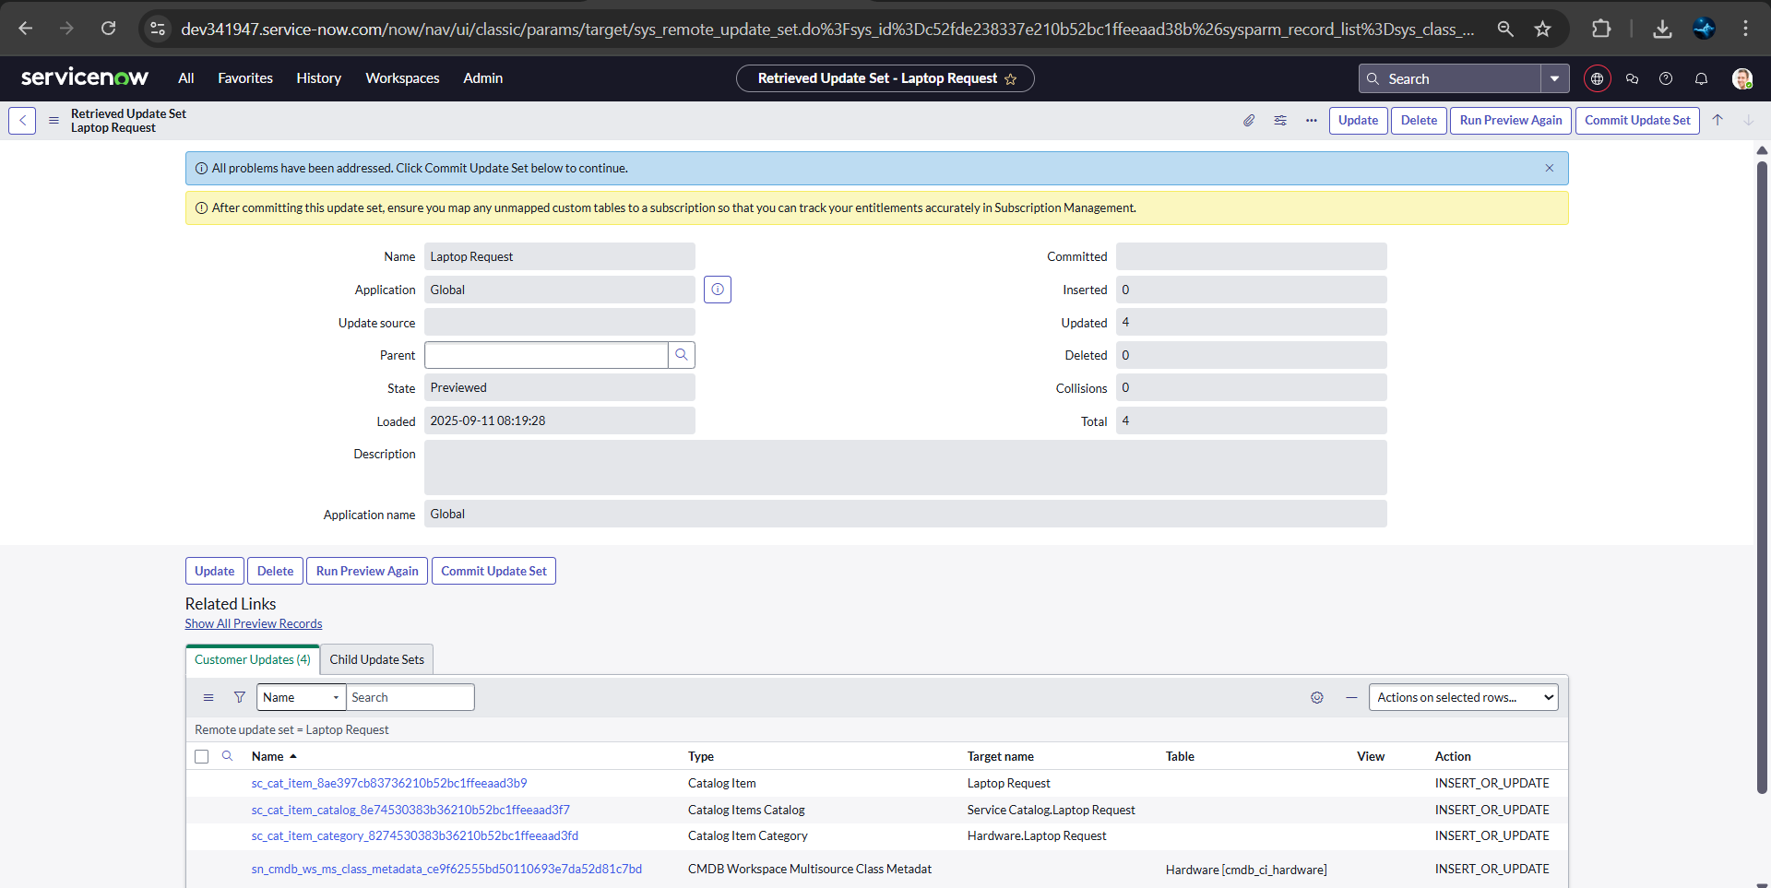13.After commiting update set in this instance we get all updates which are done in the previous instance

**Milestone 7 : Testing**

**Activity : Test catalog item**

1. Search for service catalog in application navigator in target instance
2. Select catalog under service catalog
3. Select  hardware category and search for ‘laptop request’ item
4. Select laptop request item and open  it
5. Its show three variable only

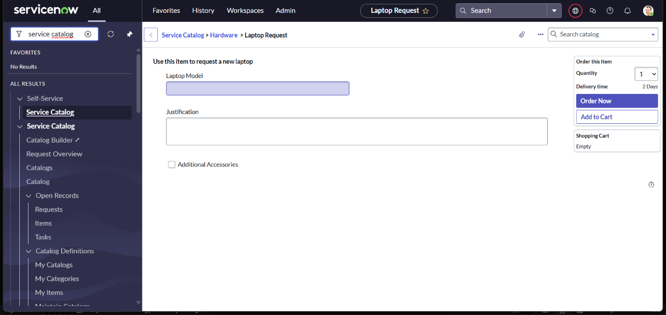

1. As per our scenario, when we click on additional accessories checkbox then accessories details fields is visible and that should be mandatory
2. Now see the results it fulfils our requirements

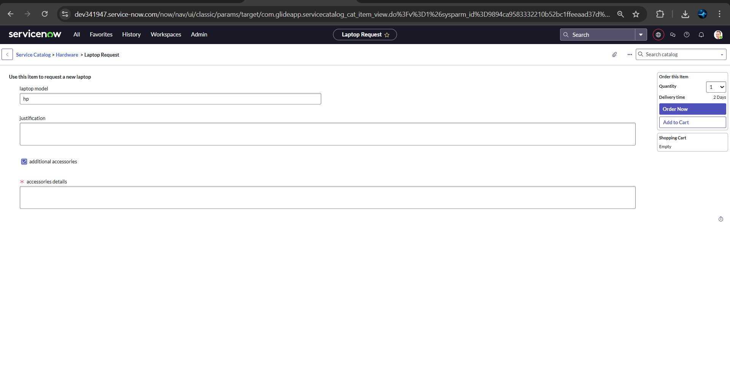

Conclusion :

  The Laptop Request Catalog Item project successfully streamlines the process of requesting laptops within the organization by leveraging ServiceNow's Service Catalog capabilities. Through the implementation of a dynamic catalog item, the project ensures that users have an intuitive and user-friendly interface, reducing errors and improving efficiency.This project demonstrates how ServiceNow can be used to replace manual, error-prone processes with automated, efficient, and user-centric solutions. It not only improves service delivery but also enhances employee satisfaction by providing a modern and streamlined request experience.